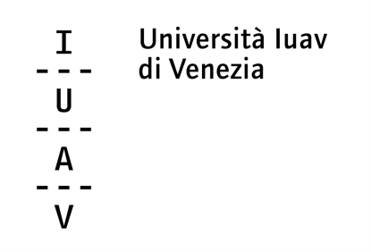

2016/2017 Student Exchange

Application form
Please complete the form with your details

DEADLINE: April 20, 2016

What scholarship are you applying for?
MA scholarship (6 months) ☐ PhD scholarship (3 months) ☐

Surname: Click here to enter text.
First name: Click here to enter text.

Your year of study and department affiliation: Click here to enter text.
Your level of English proficiency: Click here to enter text.

Please attach the following documents in the order given below in one PDF to your application email:
- this application form
- letter of motivation (300 words)
- letter of recommendation from your academic advisor at EUSP
- transcript of your academic records (list of grades)

